Vide o -20 – March-2

**EBS : Elastic Block Storage**

If you take our pc /laptop ..hard disk is embedded

EBS is a hard disk for your EC2 instance, but it is virtualized.

EBS and EC2 are two different , if my ec2 crashes , my EBS remains same, so that we can spin off new ec2 and attach with EBS.

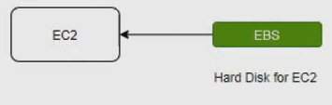

EBS is block level store, it is apersistent volume

We should use this for frequently read write operations where I/O size is small.

We can use this for workloads like relational and non relational data bases big data analytics even for web base applications etc.

It is highly durable and highly scalable. They maintain two replicas in same availability zone.

EBS is AZ (availability zone) specific , that is this volume can be used by EC2 present in same AZ.

One EC2 can have multiple volumes. We can resize the disk. Resize means we can increase but we cant decrease (if already data is there we can not decrease)

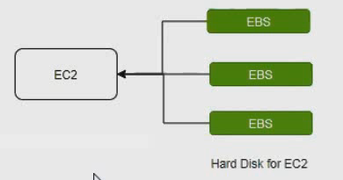

One volume can be attached to one EC2 instance at a given point of time. However you can detach from an instance and attach to another instance.

**EBS snapshots** : it is called EBS backups . we can take backups backups are stored in S3.

We can take snap shot of one AZ and restore it in another zone.

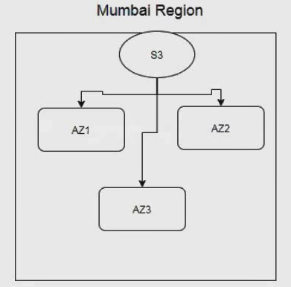

S3 stores the data of multiple AZ’s .Snap shots are incremental.

If we take a snap shot, new snap shot contains data which is modified after previous snapshot.

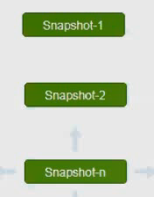

Taken first snapshot1 after some time taken snap shot…that’s snapshot 2, in that you can see first snapshot details (it is appended)…after some time if you take 3rd snap shot in which you have snapshot1 and 2 details..

So if snapshot 1 and 2 are crashed or deleted , nothing will happen we have snap shot 3 ..if snap shot 3 also deleted that will be the problem.

Taking snapshots and deleting old snapshots is common use case in every application.

We can use life cycle manage for EBS volumes. For automating creation and deletion of snapshots.

Before life cycle manager was introduced we used to write python scripts for creation and deletion of snapshots.

**Create a volume and attach to EC2 instance.**

Make sure we have EC2 instance

Create EBS volume and make sure AZ of EBS and AZ of EC2 should be same.

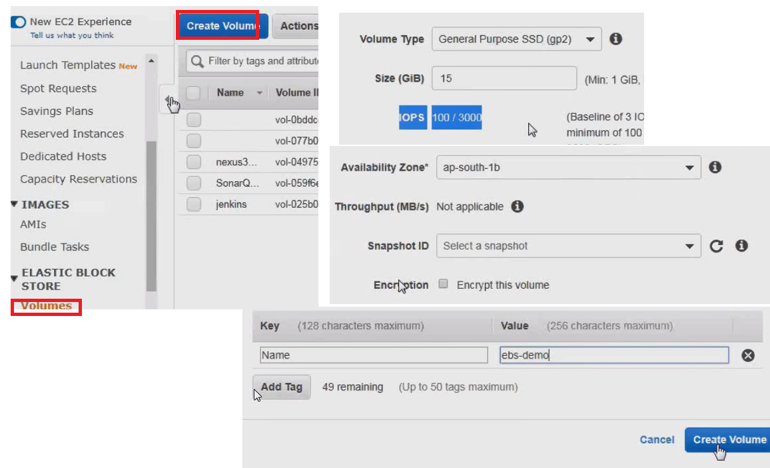

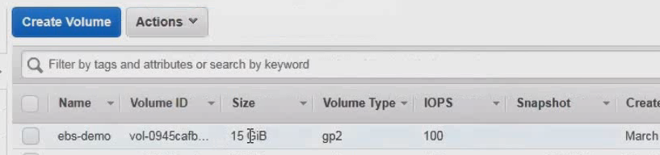

Select volume and attach to EC2 instance.

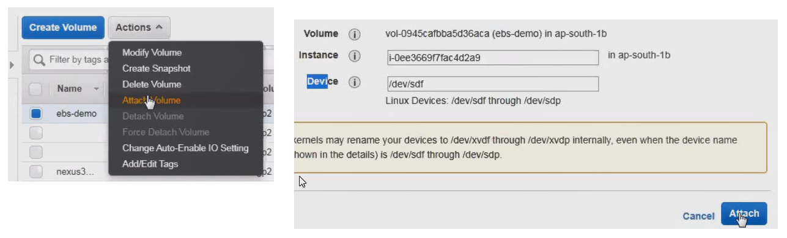

Now go for any required EC2 instance

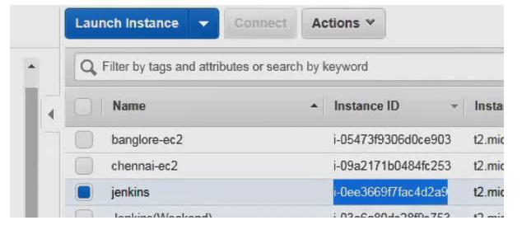

March-04

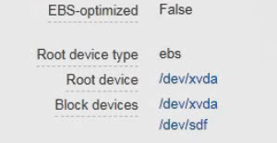

Root Device : Is a volume where OS is installed.

SSH in to EC2

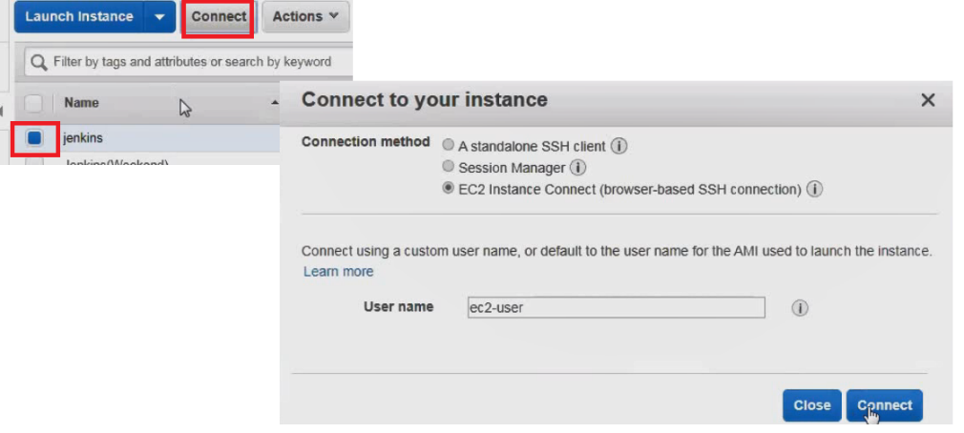

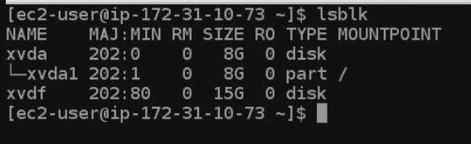

There are two disks only xvda and xvdf.

Xvdal is partition in xvda like C and D drives in our computer

Lsbk : list blocks

Create mountpoint : for mounting new disk

Create a file system on a disk

Command to create a file system.



We should not create file system if volume is created from snap shot.

Before mounting

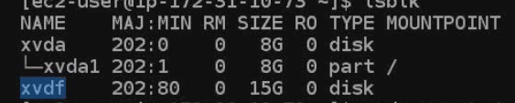

Now mount it



After mounting using above command no you can see the mydata folder

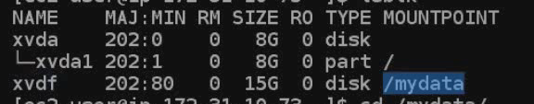

Now we can create some data here

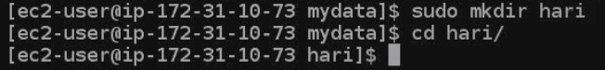

Write some data



We need to configure automount for this volume





Now write :wq

Now reboot the instance

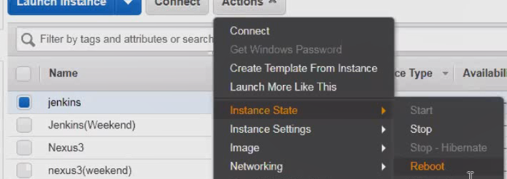

When vm reboots,

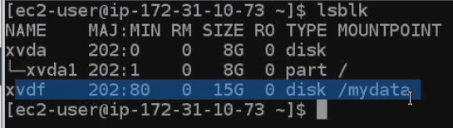

Create volume 🡪 attach to instance 🡪 login to ec2 🡪 create file system on the volume 🡪 create mout point 🡪 mount it 🡪 make entry in FS tab for automounting when system reboots.

If some one asks how to attach your volume to ec2 above is the explanation

Take a backup of volume from backup restore and attach to new ec2 instance.

How do you recover pem file if it is losed

There are several ways,

Option1 :

Detach root volume from EC2 where we don’t have pem file

Attach this volume to another EC2 which has password (pem file)

Generate new public private key pair ,configure public key on ebs volume.

Detach the volume attach it to your actual EC2 instance

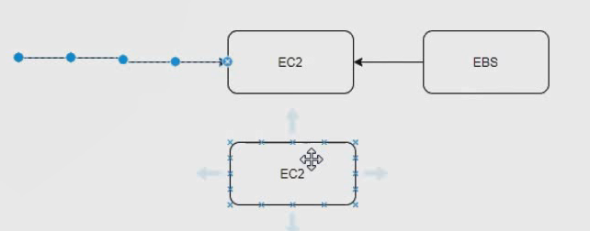

Option 2 :

Step1:Create AMI

Step2: From AMI , Launch new EC2 from AMI and select new key while launching.

**30:00**

**Select volume – actions --create snapshot**

While restoring a snapshot we can change volume type

We can migrate a volume from one AZ to another AZ as follows

Create snap shot 🡪 from snap shot launch volume 🡪 choose a different AZ 🡪 Click launch

You can copy snap shots to different regions for the sake of disaster recovery

And we want to take regular ebs snapshot. To handle disaster we want to have snapshots also in US region for that we have to copy snap shots to US region

Copying snap shots to different regions can be automated using python scripts.

Modifying

Here you should know one thing

To setup infra …we use Terraforam

Once infra is ready , we are going to perform some operations , for that we are using python automation

Modifying volume attributes : we can change volume type and size at any given point of time.

EBS encryption

EBS volumes supports encryption

Volume Types : Amazon designed different volume types for different use cases. The use cases can be running web applications.

Running Data base servers

Bigdata analytics

Datawarehousing etc.

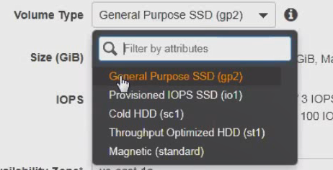

Solution architects are responsible to suggest a volume type for a given use case.

We can divide volume types in to two

|  |  |
| --- | --- |
| IOPS | Throughput |
| General purpose SSD | Throughput optimized HDD |
| Provisional iops ssd | Cold HDD |
|  |  |

Last one magnetic is not in IOPS or Throughput it is generic purpose

**IOPS** : Input output operations per second, number of writes (output) and number of reads (input)

Data base perfomrnace depeneds on IOPS, if our disk has more IOPS data base performance will be more.

We should use IOPS based volume types if we are setting up a web server , a DB server it can be relational and non relational.

General purpose SSD : Used it for Dev/Test environment we can use it for production also if application is not critical

**Day22 :**

**Provisional iops SSD :**  It is intended for machine critical applications.

It provides consistent high performance

Certification like for machine critical which one is suitable SSD

WE have to pay for STORAGE + IOPS

Max iops per volume (disk)for general purpose is 16,000

Max iops for each instance for general is 80000

Provision IOPS per volume is 64000

Certi- question

Our client has machine critical application , they need 16000 iops with a single volume as a architect what you recommend

1. General purpose
2. Provision iops --ans
3. Magnetic
4. Cold hdd

**Interviwew question**:

In aws provision iops maximum gives 80000 iops for ec2 instance, but application needs 1 lakh iops , are achive this ?

We need to combine multiple ebs volumes and create RAID0

RAID --- To achive more performance.

**HDD :** Hard disk drives

Use HDD if our application dominant performance attribute is through put per second.

Applications like depends on throughput for their performance.

If it is RDB and no sqldb then go for SDD , if it is datawrehouse and big data then we go for HDD

**Throughput optimized HDD**: Lowcost HDD VOLUME DESIGNED FOR frequently accessed throughput intensive workload.

Streaming workloads requiring consistent fast throughput at low price.

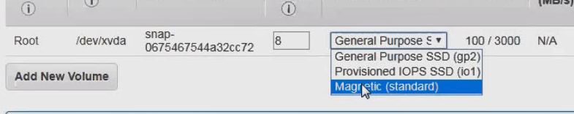

Cold HDD : the characteristic are same as throughput throughput HDD except cold hdd is designed for infrequently access.

Note :

Can I published snap shot one region to another YES

Can I attach multiple volumes to one EC2 –yes

Magnetic storage : Its previous generation disk ,not applicable for latest generation apps.

If our application is designed to perform on magnetic storage then only we used magnetic storage.

What is instant store.

Instant storage is ephemeral (temporary) storage, this disk is physically attached to host computer.

It is very very cheap when compared with EBS volume. We loose data in any of the following circumstances

The underlying disk drive fails

The instance stops

The instance terminates.

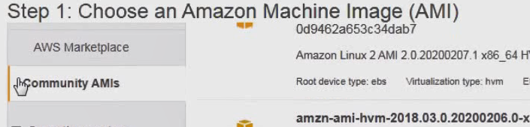

Click on community AMIS 🡪At the bottom of left menu you can see instant store –sleect it

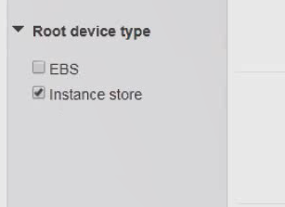

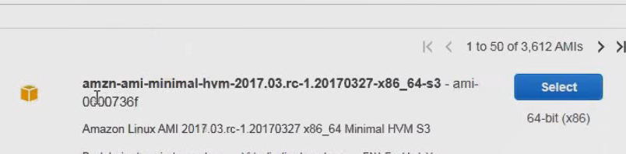

Only few isntances support…scroll down the page and select below option

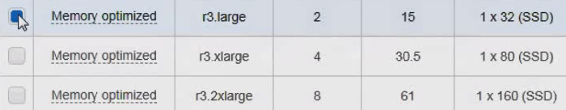

🡪Clcik next configure instance details 🡪 click add storage 🡪 click Review and launch

This is not required actually , for interview purpose only

Check AWS backup : Read and understand AWS back up ..this is home work

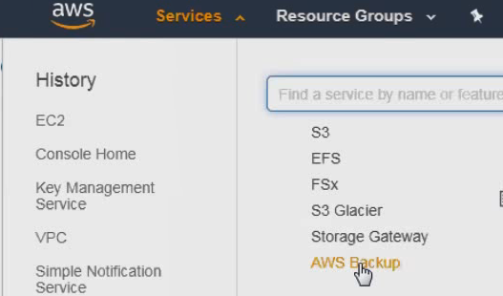

**EBS LifeCycle Manager** : Schedule and manage creation and deletion of EBS snapshots.

Steps to create snapshot lifecycle policy:

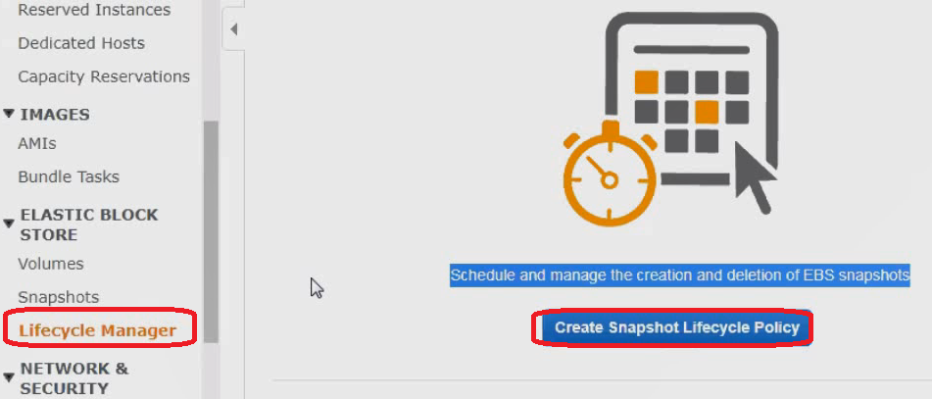

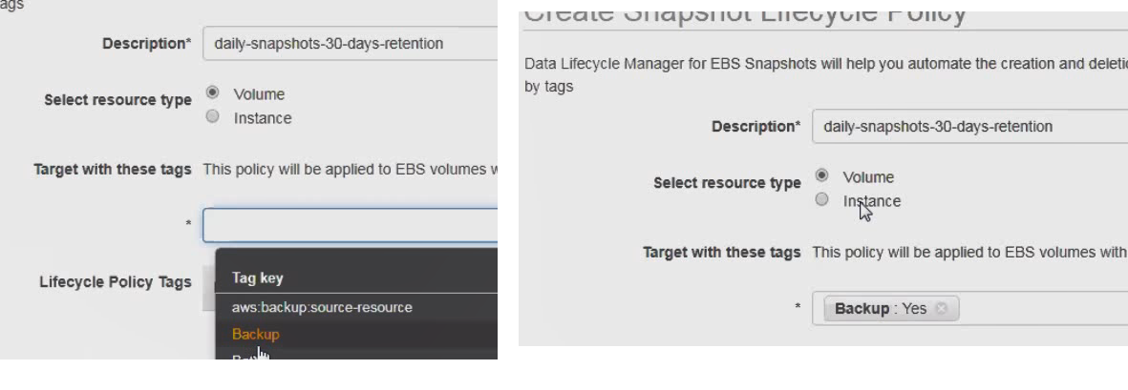

Meaning of above diagram is ..create a backup fo volume of snapshot shich is having backup as key and yes is value

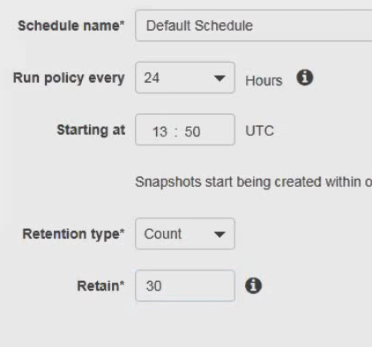

In above UTC is different time zone ..so convert your time zone equivalent to UTC and enter that value

In india

Add current time +additionally 2 min..other wise it gets expired before you create it

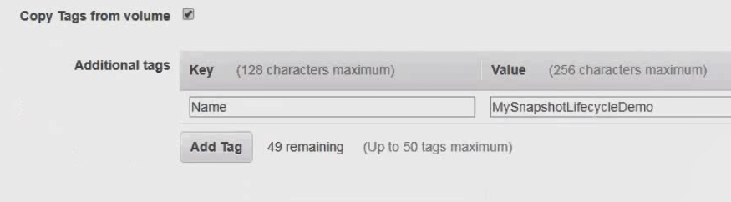

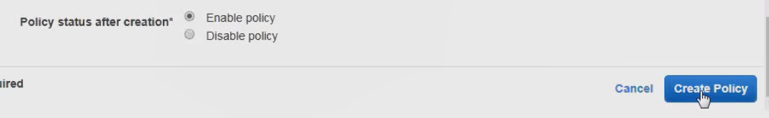

In EC2 you can see below

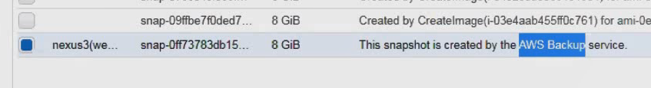

It has options to copy snapshots to different region.

Using lifecycle management create EC2 instance backups with 30 days retention. And two backups in a day (every 12 hrs one backup ) and also copy backup to Sydney region

Try same above using terraform

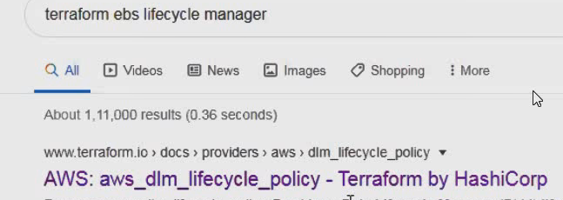

**Day23**

**Create snapshot :** Once you create snapshot , it will take one hour to publish.

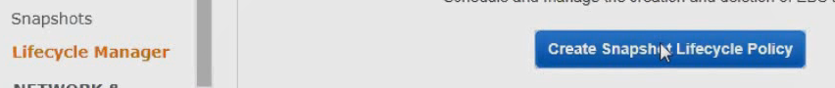

**Enter descripton and select tags**

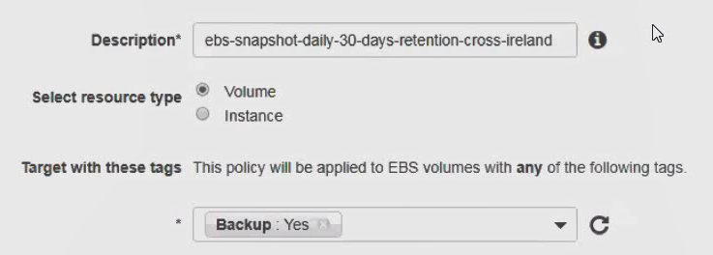

**If you want to create at local time 12:52 ..convert to equivalanet UTC and add 5 mintues extra**

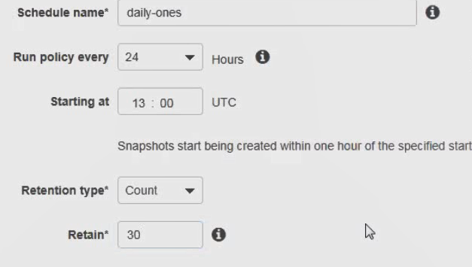

**Add tags**

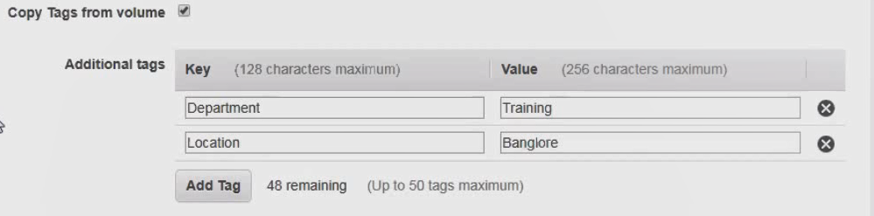

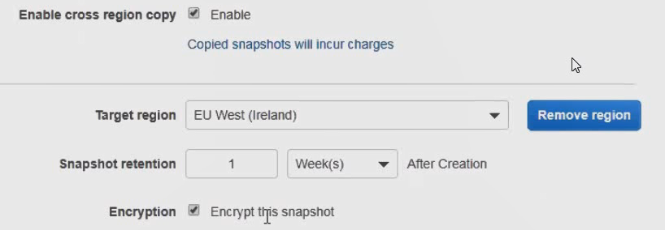

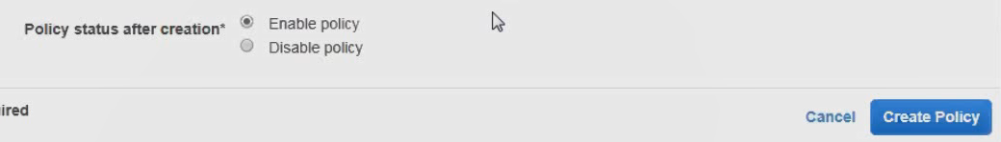

**Done wait for some time it may take 20 min or 30 or 50 min to create snapshot..**

**After some time you can see below**

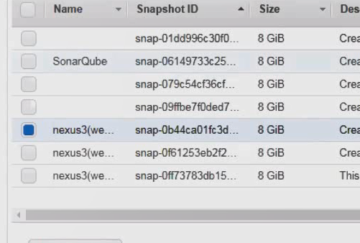

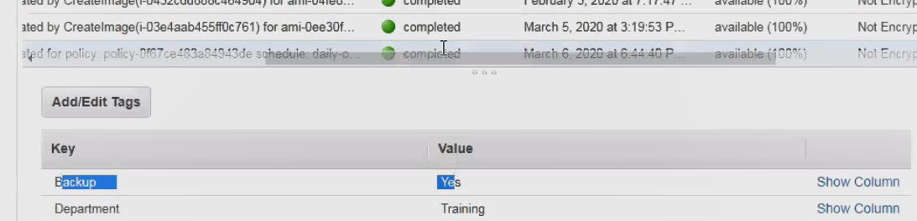

**Assume that I** want to take backup of one more volume what to da

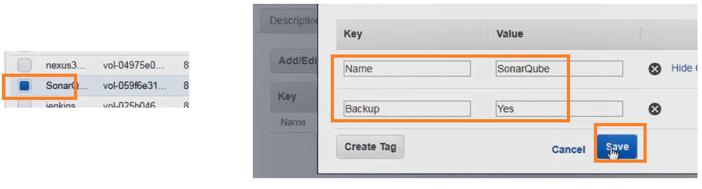

**EC2 UserData :**

**Inter view question :**

**They may ask like what is user data or at the time of launching ec2 how to run custom scripts**

**User**  data is option in EC2 where we can put custom scripts which is executed at the time of launching ec2 instances.

**For** example you want to launch 100 ec2 instances, and install java in all of them this can be easily achieved using user data.

**For** windows ec2 , we can use windows batch scripts or power shell scripts. For linux we can use shell script or cloud-init directories.

Demo : Launch Linux EC2 BY passing user data scripts

Launch Instance :

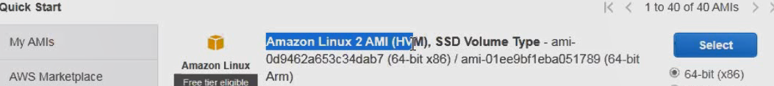

Select 🡪 click configure details –

We can put the insert script or add text files etc,

We should not use psudo for user data scripts, because by defulalt these scripts are executed under root user

If you want to host a website on apache , you need to keep ur code under var/www/html. ..so that it deployed by apcache.

You can use IP of apache and hit the server on ip4, you see your website ..that is deployment process of apache server

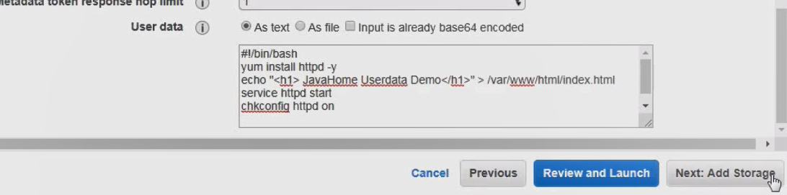

--Click on tags ---add tags –

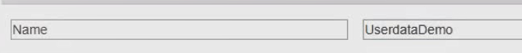

Configure security group

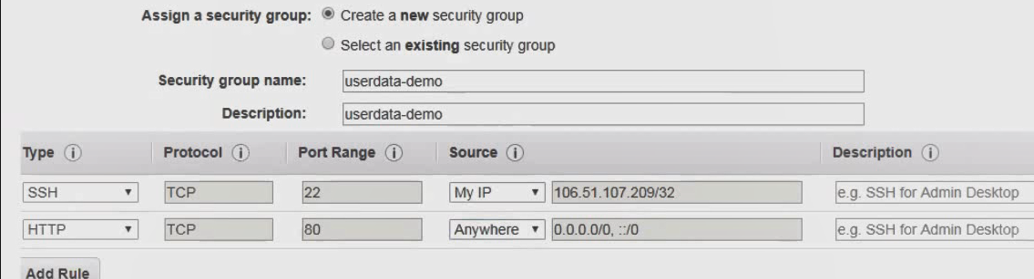

--launch –select keypair ---laucnhc services..

Get the public ip above created instance.

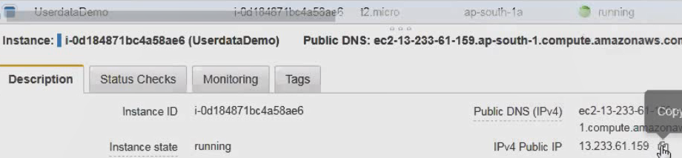

Add the above ip address in browser you can see

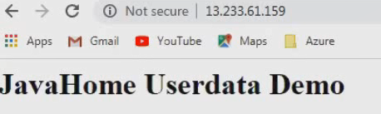

Trouble shooting user data scripts :



Open above file you can see the excpetions and trouble shoot

Try userdata using cloud in it directories

**Elastic pipeline (ESL) :**  It is a network file system in the cloud. This can be used by multiple EC2 instances.

Do u know all softwares placed in share folder of remote machine in corelogic and every one copy and install in their machine

That sahred flder is referred as ESL in AWS terminology.

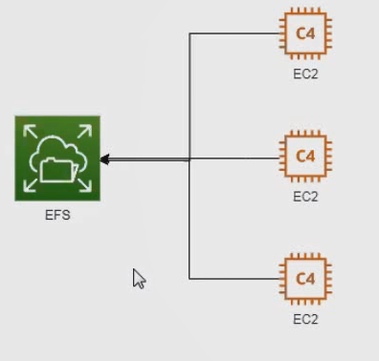

EFL we can store data only we cant run the application , where as in EBS we can run the applciations

If you keep ANY FILE IN EFS all isnatnces can see that file

Setting up EFS :

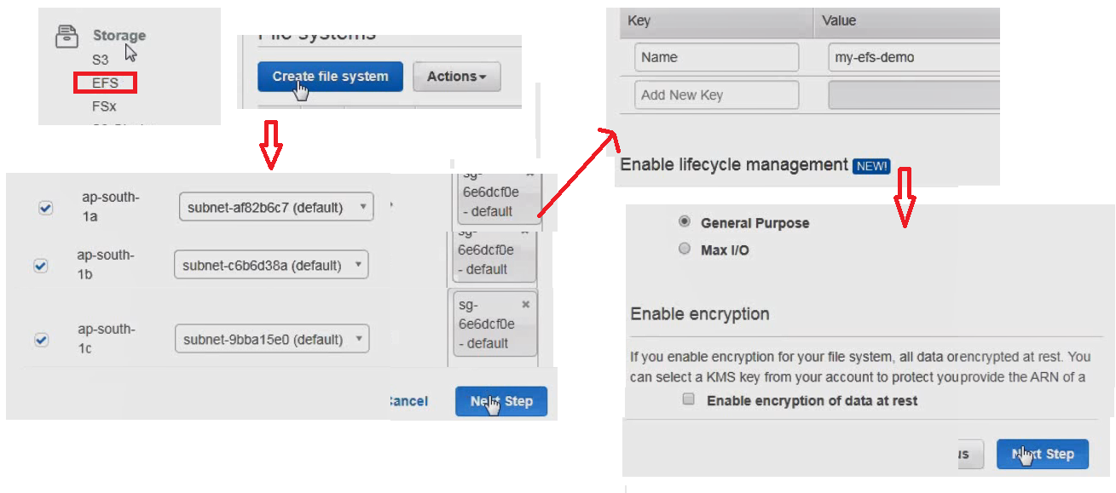

* Click Next 🡺 Click Create File System

File system created , Ec2 ISNTANCES Use this

Now launch 2 EC2 isntances and ount them to EFS

Create Instance 🡪 Click instances -- > Launch instances 🡪 Select AMI 🡪 Select t2 micro 🡪 you can create 2 instacnes at a time 🡪 In configuration Insatcnes enter 2

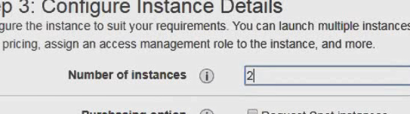

Here you can see userdata option section , it needs some packages for File system … you can see those details

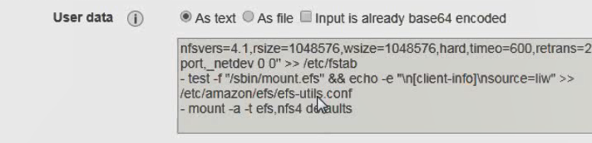

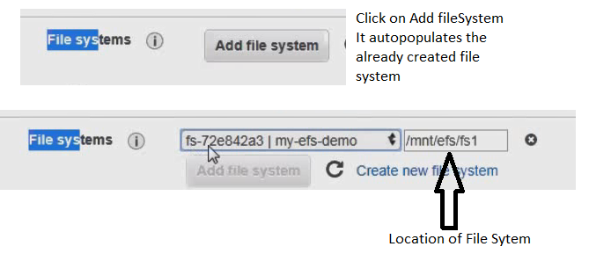

Click storage 🡪 Add tags 🡪 give some name for tag

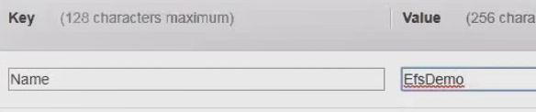

* Review 🡺 Launch
* 2 instances created as follows
* 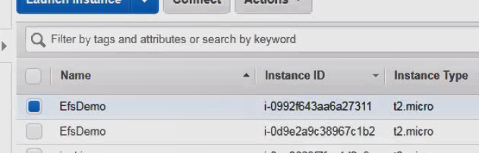
* Get the public IP of one -🡪 Connec to SSH
* 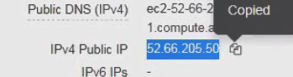

See the files in first instances, ..currently no files existing

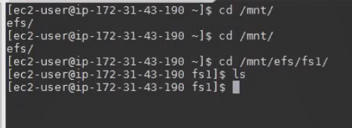

Now create one txt file

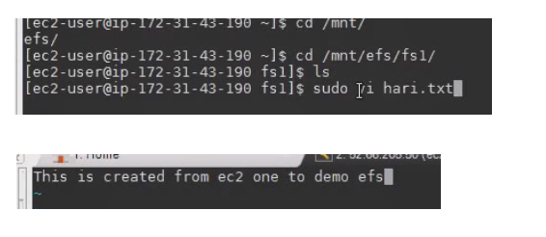

Now login to second system , you can see this file in second instance

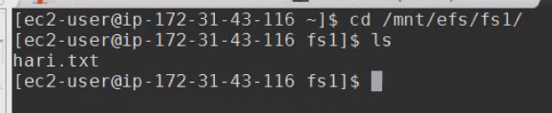

**EC2 Purchase options :**

ON Demand Instances, name itself indicates ..need something instantly

On demand we can launch those isntances and use them, we can terminate them whenever we want

I want EC2 isntances for one week in order to POC ( proof of concept)

We have an ecommerce application , Announced offers for 3 days , only for 3 days I need extra 100 EC2 instances.We are build for only for number hours we use them billing stops when we shutdown the instance.

Ondemand isntances cost is high compared to opther options.

**Day 24:** Reserved Instances :

We need to give a long term commitment to amazon usually one year or two years.

Reserved instances comes with discounts. Amazon has different payment options like

1. all upfront payment, you will get maximum discount
2. Partial upfront :
3. no upfront .

If we purchased10 reserved isntances it is a criteria linux operating system t2 micro with default tenancy



Upto 10 EC2 insatnces matching this criteria reserved falls under reserved billing otherwise ondemand

If I terminate all 10 reserved instance ,billing will not stop

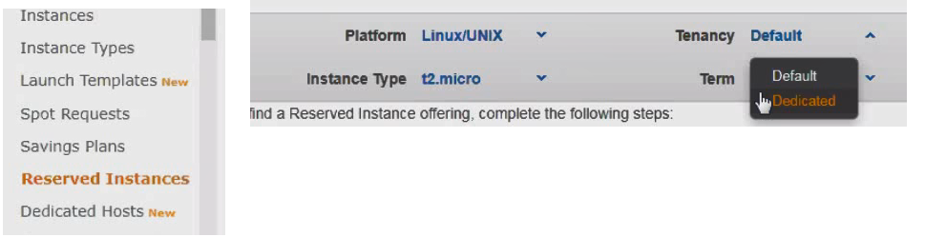

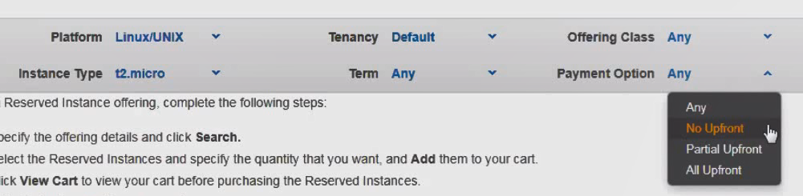



If you search for different payent options you can see price diffrence

**Scheduled Instances :** Schedule instnaces allow you to reserve EC2 instances on recurring schedule

**Dedicated Host** : here we purchase a physical host. And all our EC2 isnatcnes are placed in physical hosts.It allows to use software licenses (BYOL -Bring your own license).

**Spot Requests** : It unused capacity in amazon data center. Spot instances are purchased based on spot price.If other customers can taken out from us and allocated to customer who is paying more than us.

Spot Instance interruption – Amazon EC2 terminates, stops, or hibernates your Spot Instance when the Spot price exceeds the maximum price for your request or capacity is no longer available. Amazon EC2 provides a Spot Instance interruption notice, which gives the instance a two-minute warning before it is interrupted.

**Day:25**

Can I use DB in spot instance : no it is not right choice..there may be inturpution

Can I use my website in spot instane : no it is not right choice..there may be inturpution

**Placement groups** :

It is logical group of EC2 instances

EC2 service apptemt to place the instance in such a way that all of your isnatnces are spread out across underlying hardware to minimize correlated failure.

Placement strategies or types are

Cluster : Usefule for HPC (High performance application) applications

Partitions : spreads your instances across logical partitions such that groups of instances in one partition do not share the underlying hardware with groups of instances in different partitions. This strategy is typically used by large distributed and replicated workloads, such as Hadoop, Cassandra, and Kafka. Spread : strictly places a small group of instances across distinct underlying hardware to reduce correlated failures

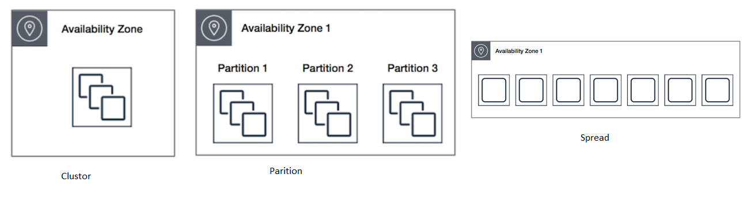

**EC2 Termination Protection** : It protects against accidental termination

To help protect against data loss caused by accidental termination of an Amazon EC2 instance, consider the following options when configuring your EC2 infrastructure:

Enable termination protection. Termination protection prevents an instance from being accidentally terminated by requiring that you disable the protection before terminating the instance. For more information, see [Enabling Termination Protection for an Instance](http://docs.aws.amazon.com/AWSEC2/latest/WindowsGuide/terminating-instances.html#Using_ChangingDisableAPITermination).

EC2 Instance Types : AWS provides wide range of instance types

They have varying combination of cpu memory storage and networking capacity.

**Family :**

General purpose : they provide balance of compute memory and network resources.

It is intended for dev/test environments

|  |  |
| --- | --- |
| General purpose T family | General purpose M family |
| It provides a baseline performance eventually it can burst above baseline  For example u r using t2 micro which have 1 cpu per baseline | M family doesn’t have concept of cpu credits.They always provide consistent perfomrnce |
| Number of credits depends on size.  Ocasianlly we want more than one cpu if there are credit points available for this instance |  |

Compute optimized : Its designed for applications which depends on cpu performance.

Scenaios : Batch processing , distributed analytics

GUP Instances : providing graphic processing units along with high cpu and network performance for applications benifiting

Memory optimized: lowest cost per GB of ram

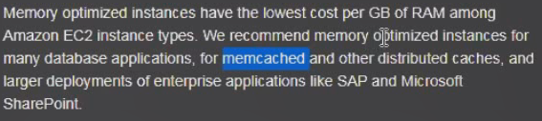

Storage optimized : It is for databases

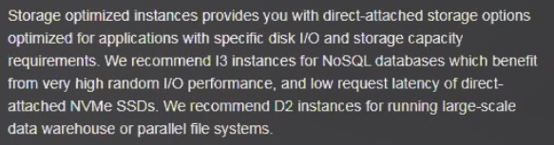

Resizing Instances : You can change the size of instance when the instance is in stop stage

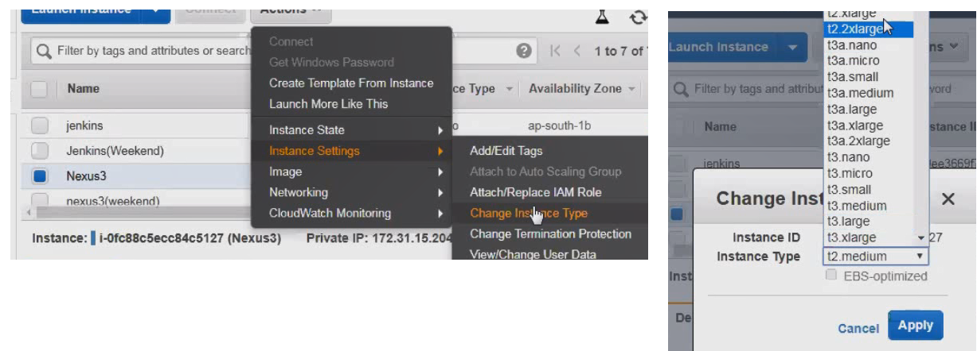

You can not change the instance type whicle instance running.

**Day26 : First 40 minutes ..certification questions**

**ELSATIC LOAD BALANCER :** It distributes traffic across multiple backend ec2 instances.

It increase high availability of and tolerance of application.

Third party load balances like nginx ,f5,haproxy etc

AWS has three types of load balances.

1. Elastic load balancer
2. Application load balancer
3. Network load balancer

Elastic Load Balancer ( ELB) :

It supports internal (private) load balancing and external load balancing. Using security group we can secure load balancer

Load balancer support http and https

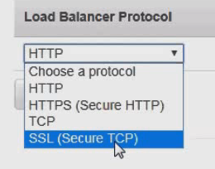

To route traffic only two healthy intances.

Https : user sends data in encrypted format and server decrypts and uses in application

How this encryption and decryption works: There are two keys like public key and private key , public key uses for encryption and private key uses decryption.

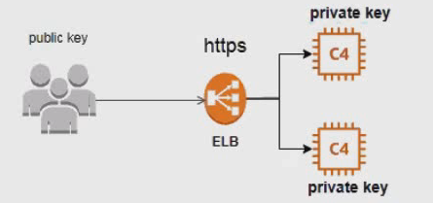

It supports SSL termination : If we configure HTTPS protocol clients will send encrypted data over over secured connection to process of decrypting the data and closing secure connection is called as SSL termination

Its highly recommended ELB to perform SSL termination

SSL termination is expensive operation, it consumes more memory and CPU.

**Day27:**

Lab session for load balancer , create two EC2 instances with default settings

Enter below details in configure instance page.

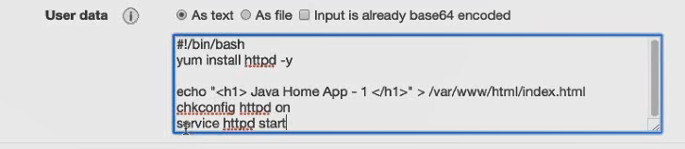

Add tags

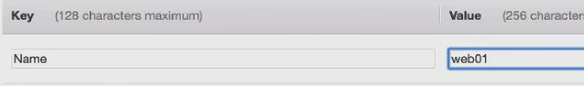

Do below settings

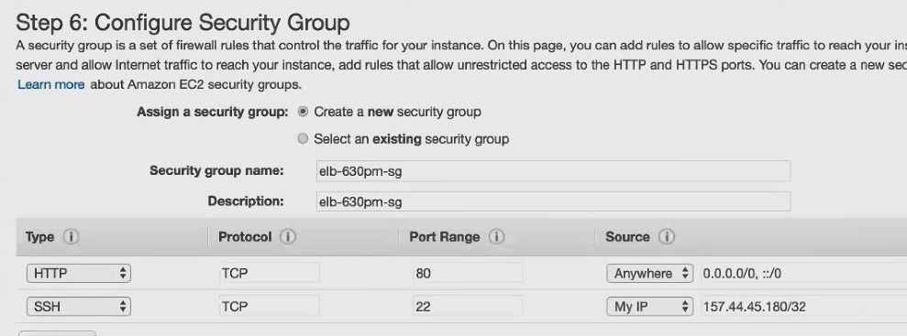

Review ==launch ===select Key

Enter the public key of EC2 in browser

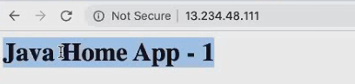

Create one more EC2

YOU CAN create new one copying above one.

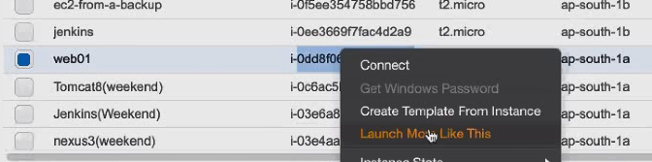

Once copyied change isntacne details change APP-2

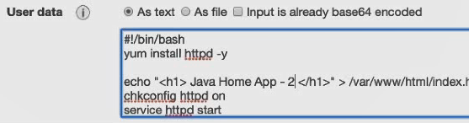

EDIT TAG as well

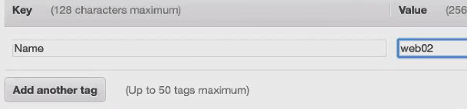

Review launch and select key

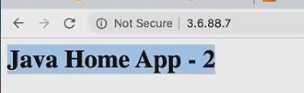

Now we have 2 intances

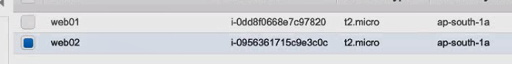

15:50 –starts create LB

From left side menu 🡺 Load Balancers 🡺 Create Load balance 🡺 Click create on classic load balancer

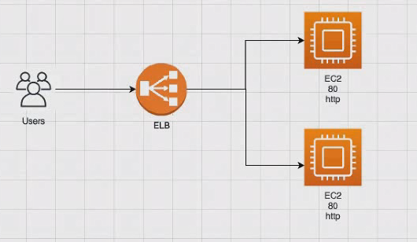

If you are configuring the load balancer for production scenario ,..loadbalancer protocol is HTTPS and port is 443

For dev and test we can select http and port as 80

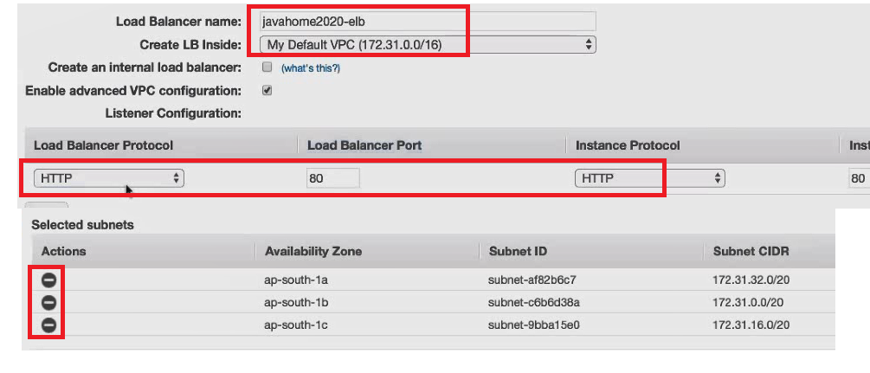

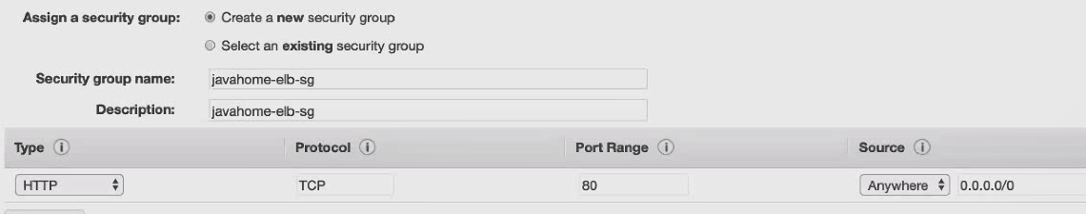

In real time , we can get healthcheckup details from developers

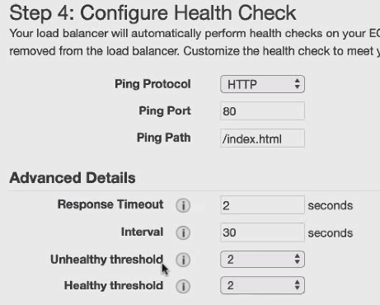

Add tags

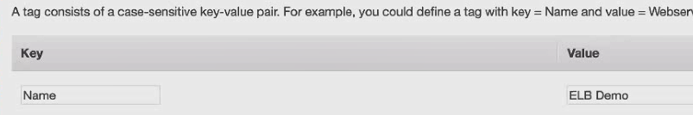

Finally click on create

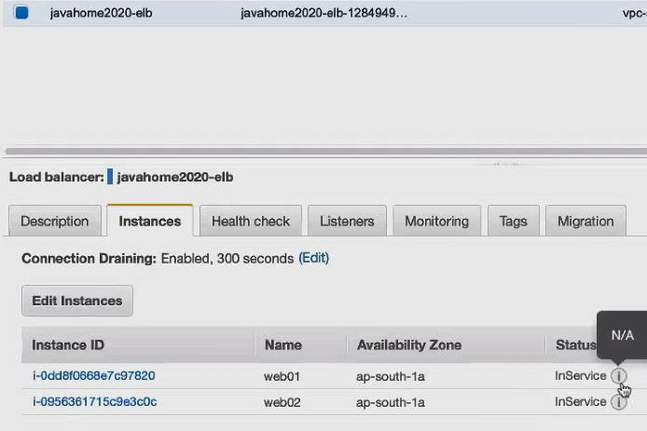

We wont get IP after creating Loadbalancer, we will get DNS, ..copy it

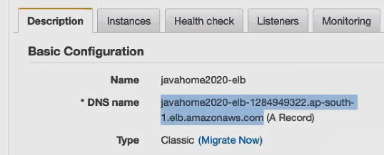

See below in

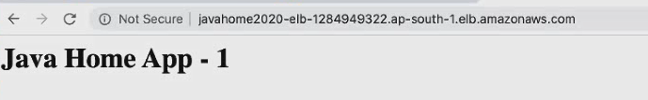

If you keep on regreshing the page ..traafic is routing ..page title will change app-1 to app-2 ….

ELB is round robbin policy.



Request from ELB ..request 1,3,5,7…will go to top instance and 2,4,6,8 will go to bottom instance this what called round robin .traffi is routing in round robbin between the instances.

**Cross zone load balancing :**

There are 2 ELB in two different zones, every since is getting same load

If cross zone load balance is enabled , every ec2 instance will get same amount of load.

If cross zone load balance is disabled , every zone will get same amount of load

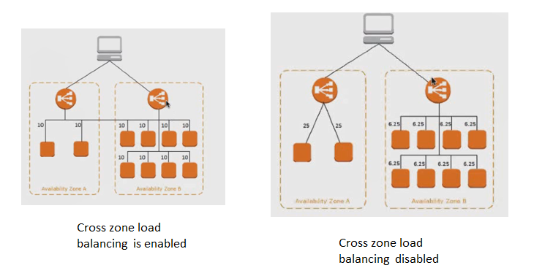

**IDLE Time :** This setting allows you to specify the length of time that a connection should remain open while in an idle state. Default time out is 60 sec.

Access log : Elastic Load Balancing provides access logs that capture detailed information about requests sent to your load balancer. Each log contains information such as the time the request was received, the client's IP address, latencies, request paths, and server responses. You can use these access logs to analyze traffic patterns and to troubleshoot issues.

We can enable the access log

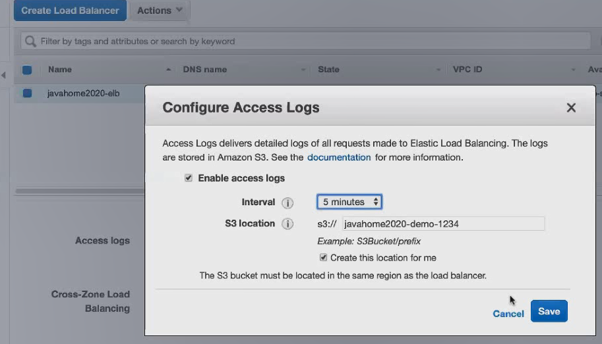

After save go to buckets you can see the logs

Connection draining : Allows existing requests to complete the load balancer shifts traffic away from deregistered or unhelath backend instance.

Stickiness : If stickiness is enabled request from a specific client always routed to same EC2 instance and specific EC2 instance.

**Day28:**

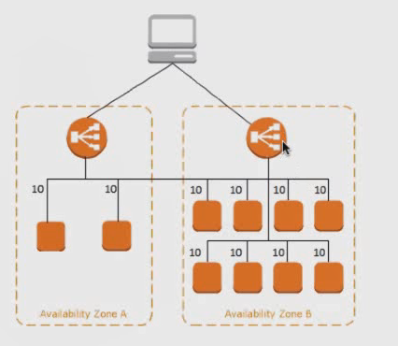

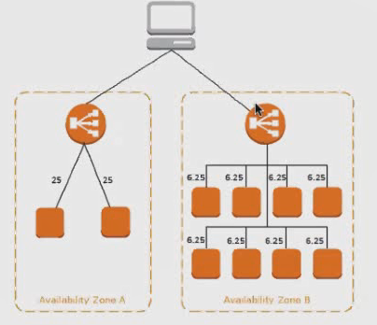

If you enable stickiness, request from a particular user always routing to a particular ec2 instance (no round robin concept here, if you enable stickiness)

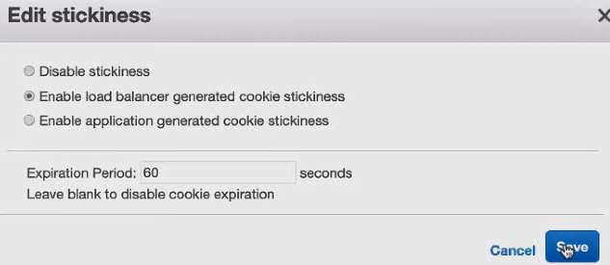

Based on cookies in user’s browser , load balancer will decide the user belongs to which instance ,that’s is how stickiness works.

At any point of time we can include the instances to load balancer or exclude from it.

**Application Load balancer :**

Choose a application load balancer when you use flexible feature set for your web application with HTTP and HTTPS traffic.Operating at the request level application load balancers provide advance routing and visibility features targetd at the application architectures including microservices and containers

Microservices : Though it look likes one application , in backend it was components /business units divided in to small units and designed as micro services.

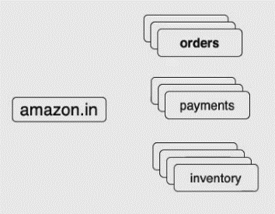

Normally We are going to design each elb for each microservices, but in Application load balancer we are going to only one load balancer for all icroservices.

We need to create ALB , and create a listener to ALB UNDER THIS listenr we create rules to rout the traffic.

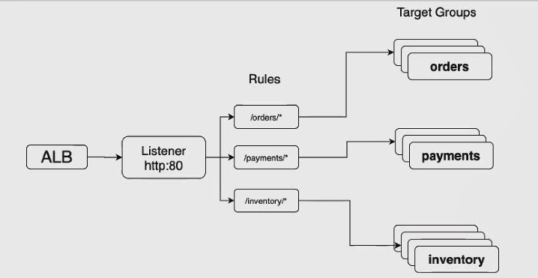

When we go for ALB ---in micro services and docker containers we go for ALB.

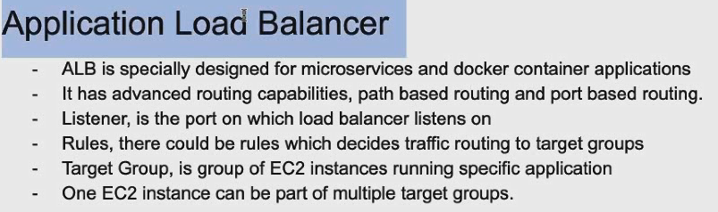

First we need to create Target groups 🡪 Create ALB ----Create Routers , now apply rules.

Step1 : Create 3 EC2 instances for order ,payments and inventory.

GET THE Public ip of instance ..run below command

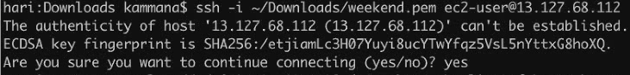



Create the application orders

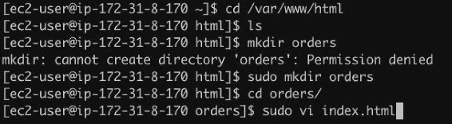



Close the file by entering :wq

Now start the server

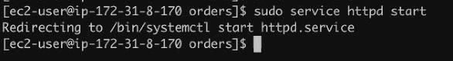

Open browser and instance ipaddress/orders/index.html,…. You can see below

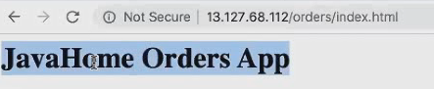

Following command starts apache when I reboot my instance.



We need to create one more isntacne for payments..

Copy the orers isntacne and rename it..

Now using ipaddress connect to second instance through sh

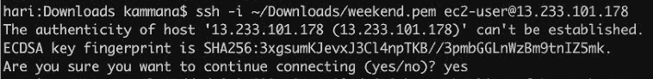

Repeat same steps as above



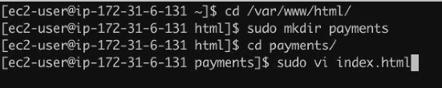

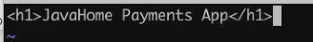



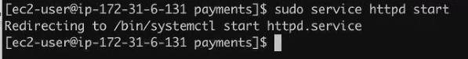

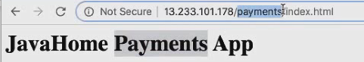

Now create target groups

EC2 left menu 🡪target groups 🡪if you have any groups already (delete them)

🡪clikck on create target group 🡪

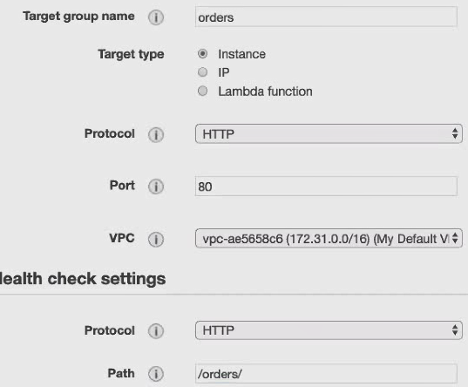

Click create

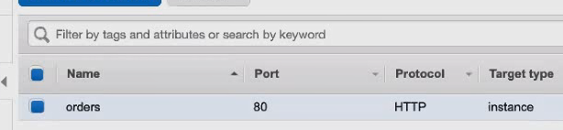

We created targets , no we need to add it

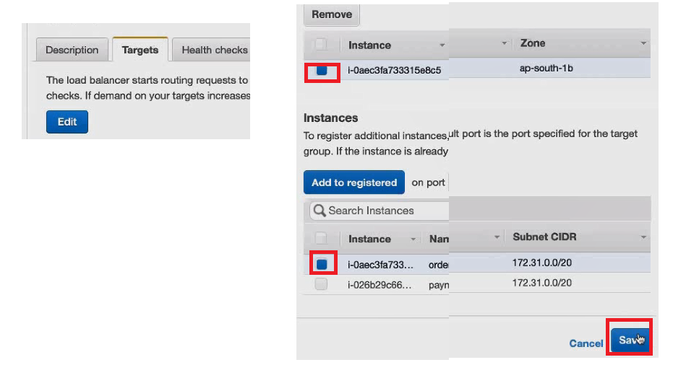

No in same way create another target group for payments as we did above for orders

So lets recap

1. Created one instance for orders and one for payments.
2. Created orders target group and payment target group
3. Orders target group added to EC2, and payments target group added to EC2
4. Now we have two target groups with one instance registered

Now we need to create load balancer (this time it should be Application LB

From left side menu 🡺 Load Balancers 🡺 Create Load balance 🡺 Click create on Application load balancer .

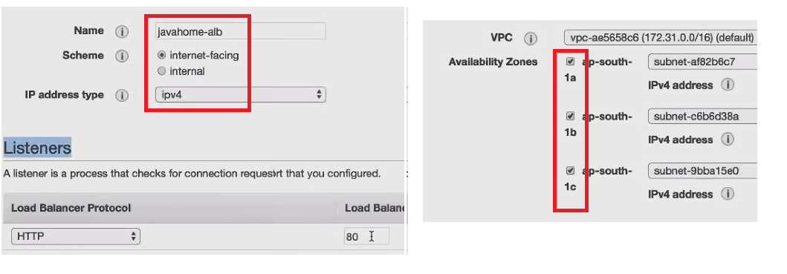

Click on security settings 🡪 in next page we are not using http so that page is blank 🡪 click on security groups 🡪

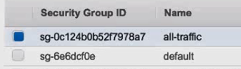

Click on configure routing.

Now we need to implement the rules.

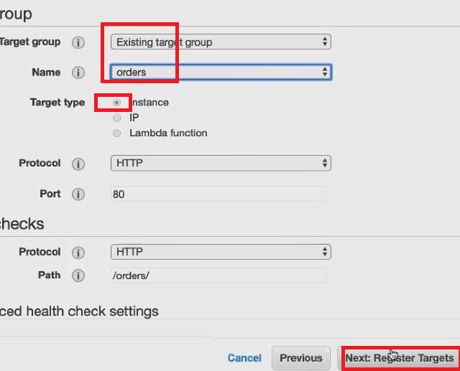

Review 🡪create 🡪 close

Now repeat the same for payments.

From left side menu 🡺 Load Balancers 🡺 Create Load balance 🡺 Click create on Application load balancer .

Now goto orders loadbalancer

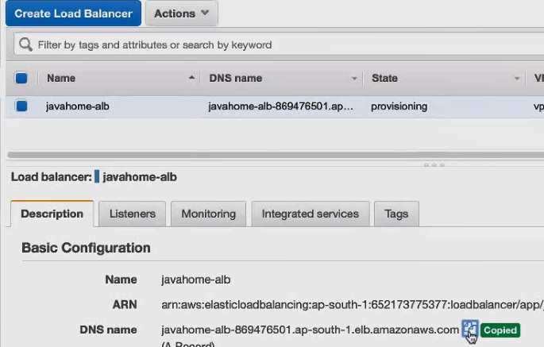

Copy above DNS name and place in browser..refresh couple of times (wait for sometime)

You can watch same session in youtube

<https://www.youtube.com/watch?v=WLu41jAYjYk>

**Day-29**

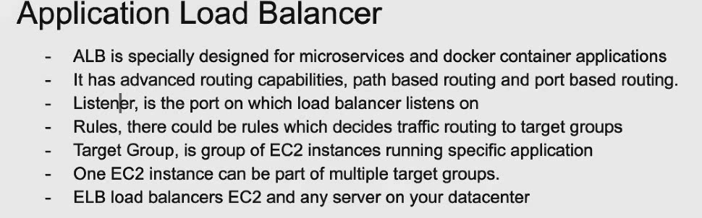

Edit the rules

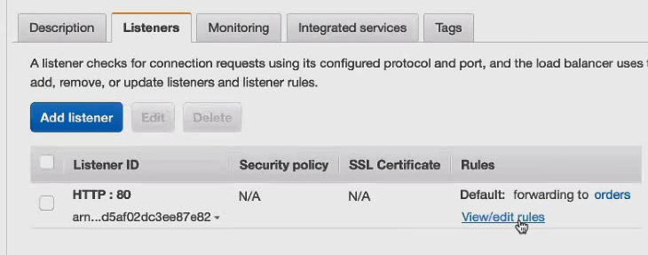

Click on edit rules

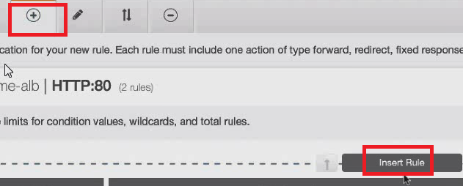

Click top + and click on add rule –add condition ---select path ---/orders/* click on add action ---click on forward to 🡪 enter

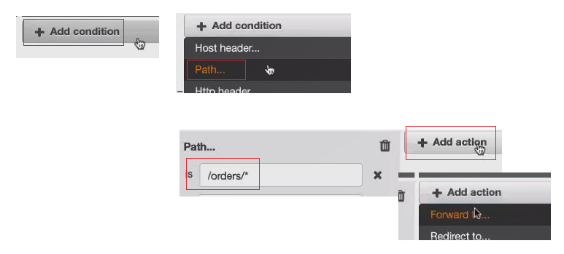

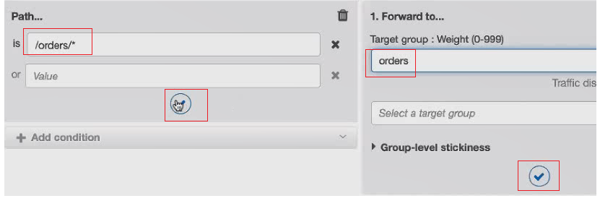

Click on both Tick marks –which saves and finally save at top right save button



Similary add payments rule…finally u can see like as follows

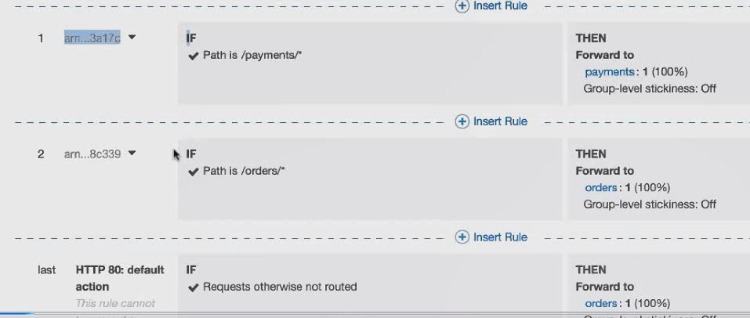

After configuring take public ip/orders/ ….you can see below page

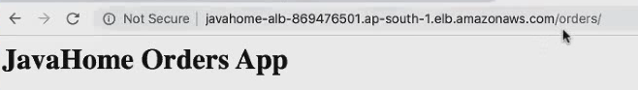

Check the payment rules.

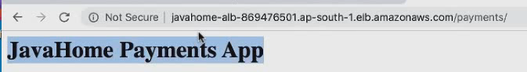

You can get mandatory question in certification from Application load balancer

Rad all above points

Once practice is done delete order and payments instances and load balancers as well

**Network load balancer:**

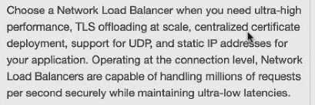

**Auto Scaling:**

Auto scaling adds/removes EC2 instances based on scaling policies.

Auto scaling feature is free in amazon.

If autoscaling launches ec2 , we have to pay.

Auto scaling performs horizontal scaling.(increase /decrease number of ec2 instances)

Vertical scaling means resize the instance (resize means increase CPU and RAM memory)

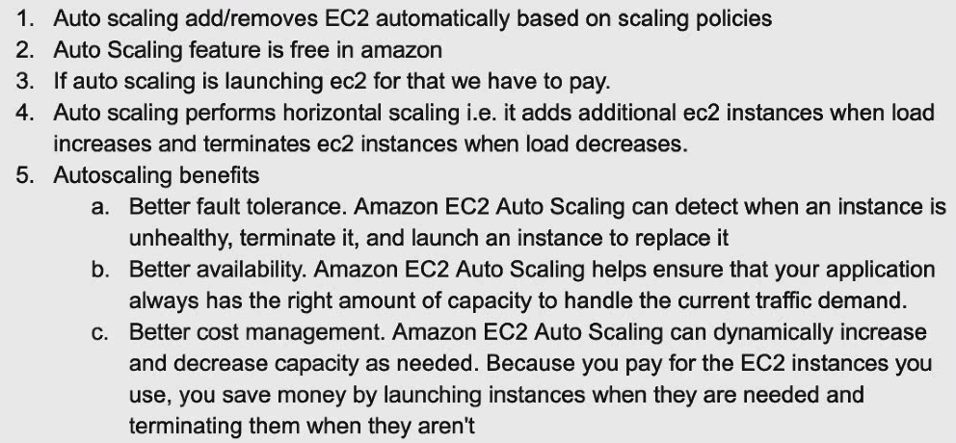

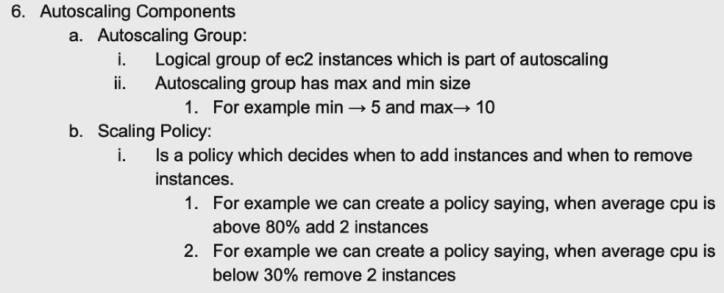



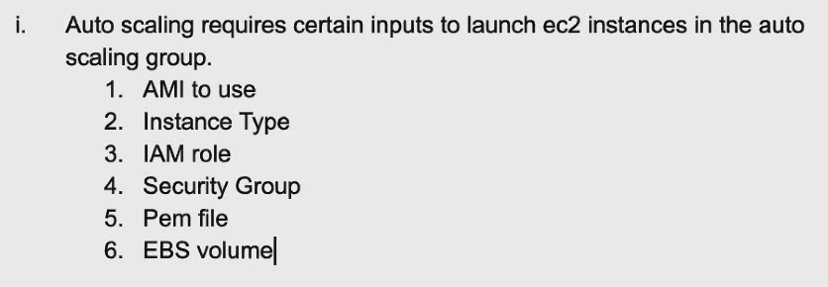

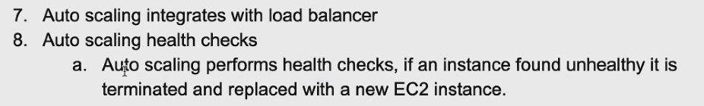

**Auto Scaling Demo :**

Step1 Make sure you have ELB

**Navigate to classic LB**

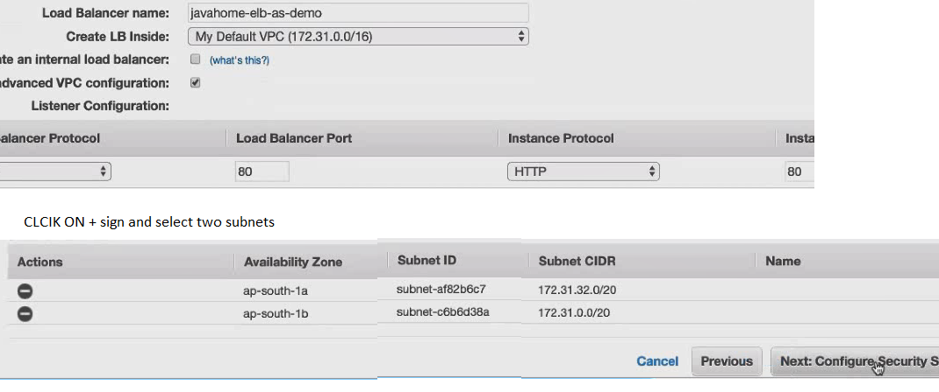

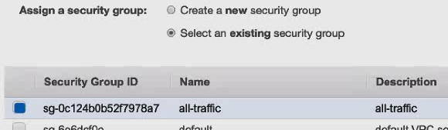

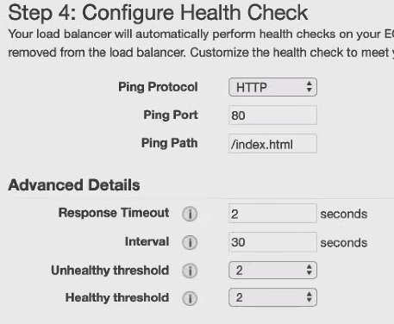

Now I am creating empty load balancer (later in autoscaling we can create multiple isnatcnes in autoscaling and add to load balancer)

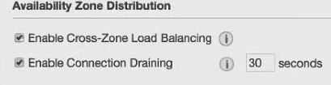

Review –create and Close

Load balancer is created.

Step2 : Make sure you have custom IAM with your application configured.

Create EC2instance

Choose AMI 🡪Click configure instacen details 🡪Add storage --add tags –

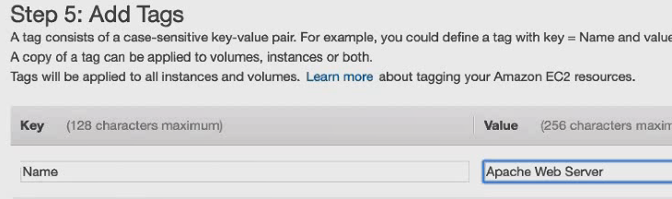

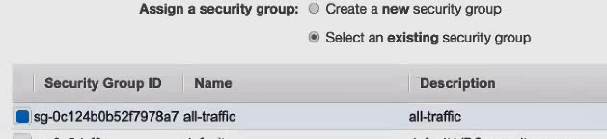

Review an Launch

Launch –select Key

Once isnatcne is created grab the public IP

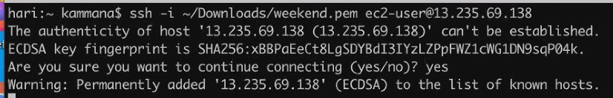





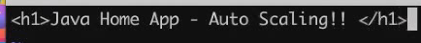

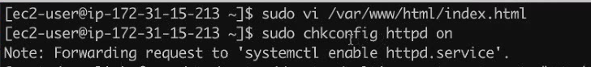

Step 3 : Create Launch Configuration

In left side menu -🡪 Under auto scaling –click launch configuration 🡪 Create Launch Configuration 🡪choose custom AMI



CLICK configuration details == >

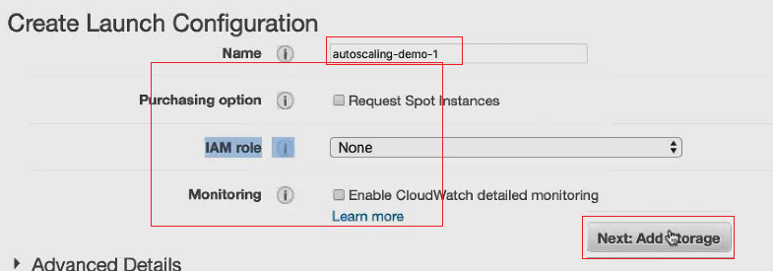

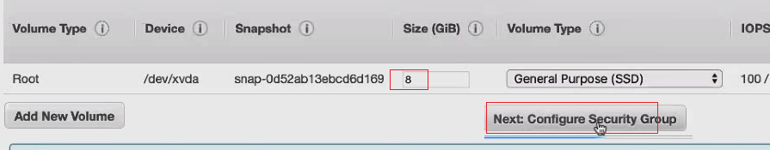

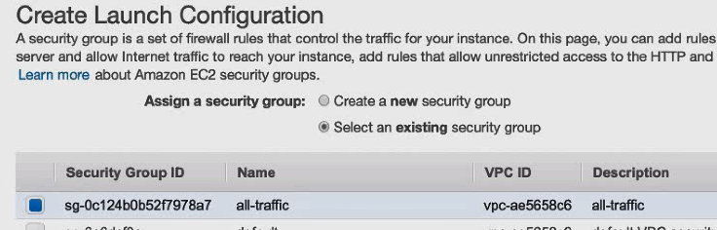

Click Review

Create launch configuration -- >select Key 🡪 create launch configuration 🡪 close it

Step4: Create Autoscaling Group

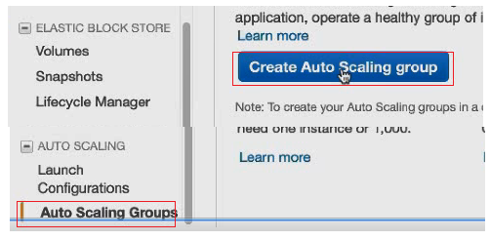

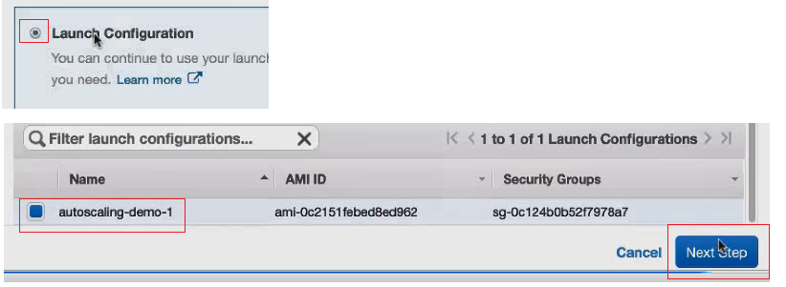

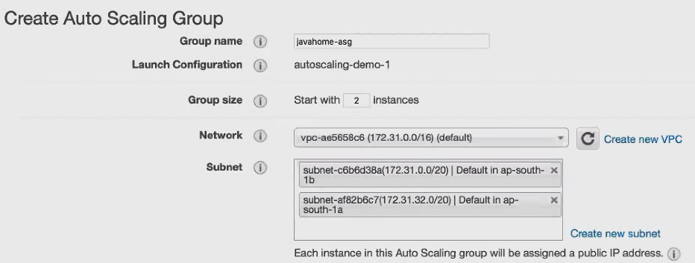

Select only two subnets because in step 1 you select 2 subnets check once

Now in same page click on Advance details

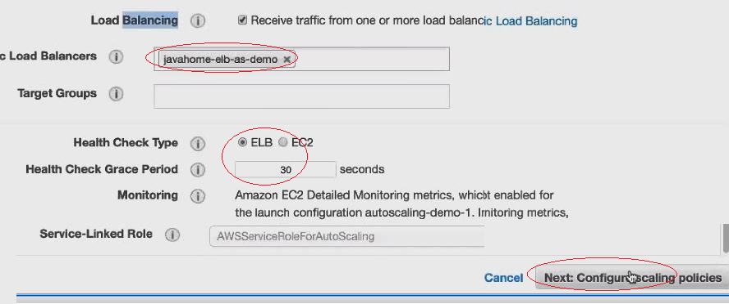

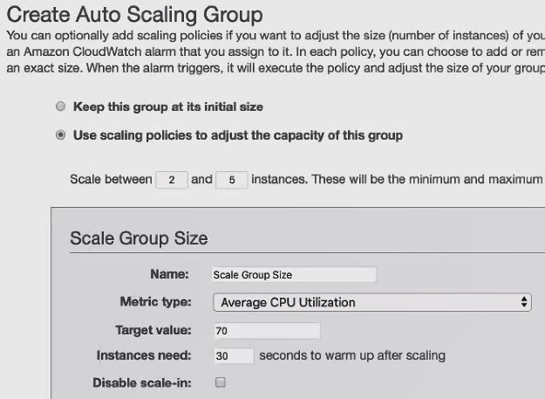

Click configure tax 🡪

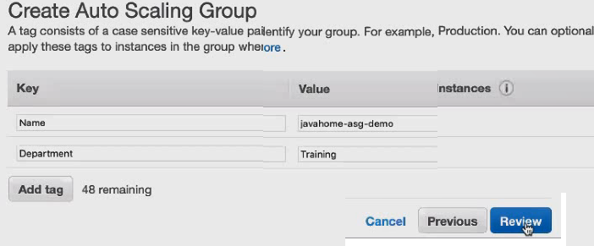

Click review –click create auto scaling group – close

In active directory you can see 2 isnatcnes

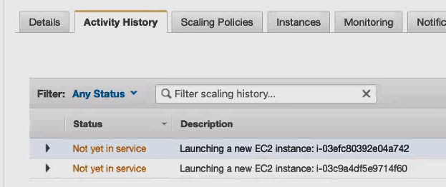

If you go to the load balancer you can see two insrnaces

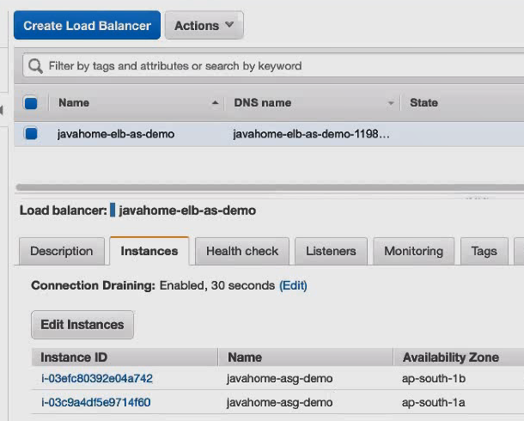

Take dns name from load balancer ..and place in browser ..you can see below

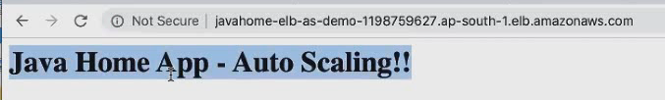

Actually you created 2 instances , intentally you stop one isnatcen …that will become unhealth …so now you have only one instance …but you configured 2 isnatcens in auto scalling …to maintain that 2 …system automatically creates one istance ….

Stop one and try to refresh …you can see new instance creation

Once demo is done …delete them or disable them.

**Day 30:**

Create a autosaclling group.

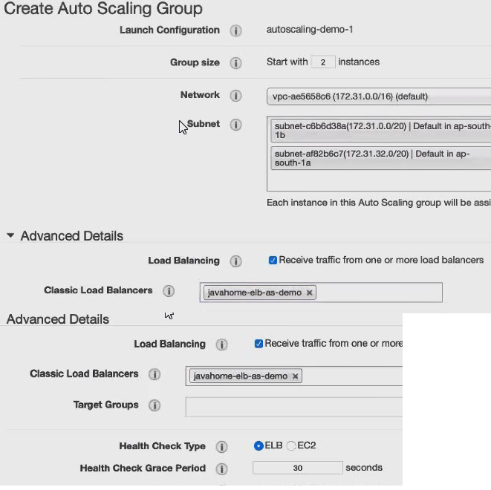

**Click on** configure scalling policies.

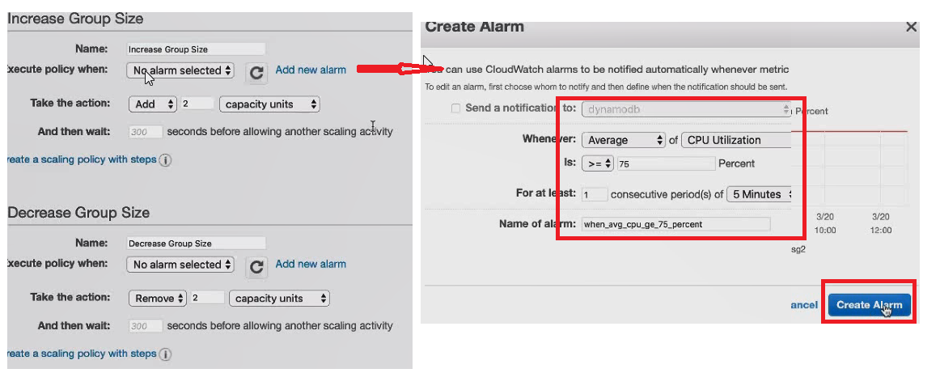

Simililarly decrease the size and add alaram

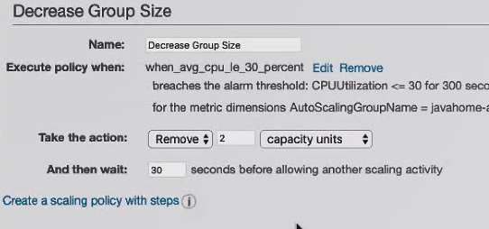

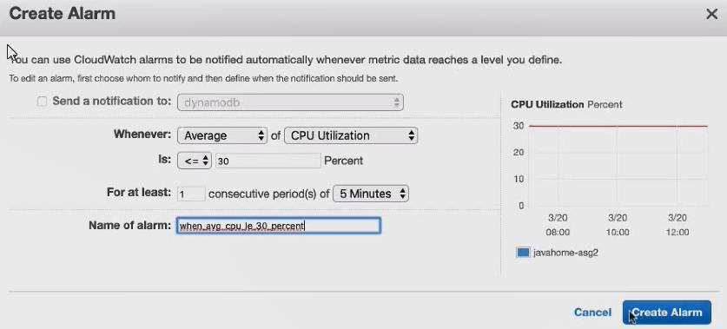

Click on configure tags 🡪

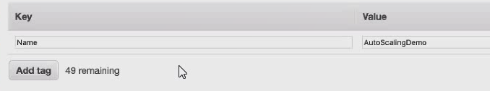

Click review -🡪 create Autoscaling group—close 🡪autoscaling group created ---now see policy type is simple scaling.

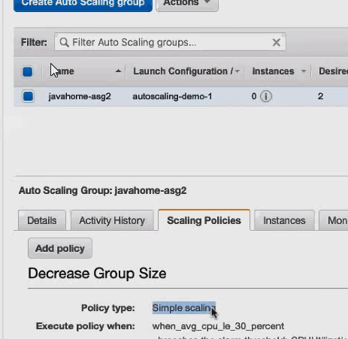

At any point of time we can delete edit the scaling policies

Go to the load balancer from left side menu 🡪

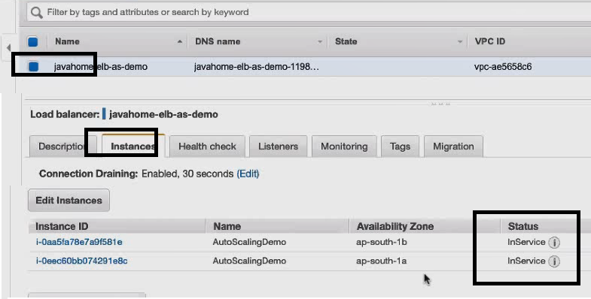

They are in service…go to description get the DNS name place in browser

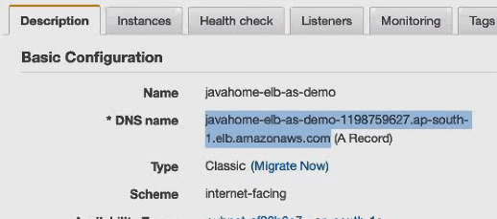

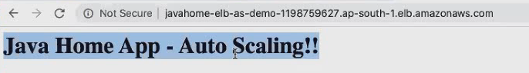

Assume that you are running web application in EC2 instane ..suppose if you terminate EC2 ..what happened to applogs

Before terminating EC2 we need to send app logs to S3 or splunk or cloudwatch logs

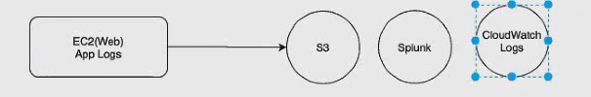

**Auto scaling life cycle hooks** :

In auto scalling group, before EC2 instance is kept in service we want to install a software or before ec2 instance is termination from autocalling group we want to ove log files from ec2 isnatcne to S3 bukets how this can be acived.

It can be achived using auto scalling life cycle hooks

<https://docs.aws.amazon.com/autoscaling/ec2/userguide/lifecycle-hooks.html>

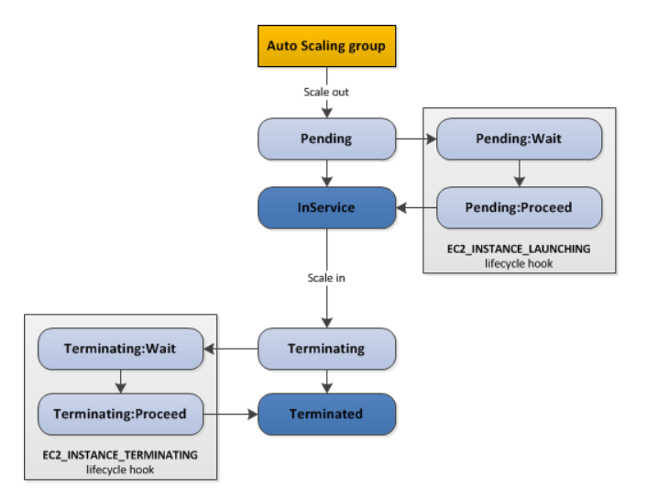

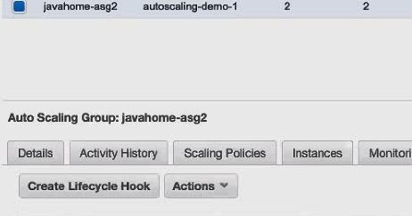

Click on above create lifecycle hook

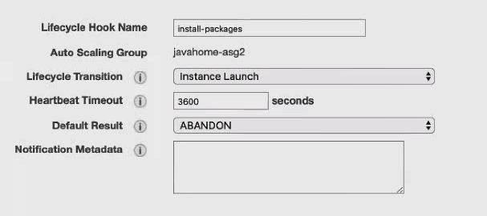

Click create ….like wise you can create one more lifecycle hook

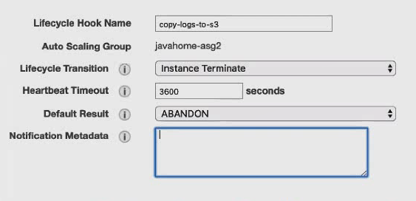

Like wise we can create one for launch and one for terminate

We can do same configuration using cloud watch

**Auto scaling schedule Action** :

You can scale your application based on schedule

For example we have a website and it get heavy traffic between 7 to 9 am then we can schedule scaling to meet our traffic demands.

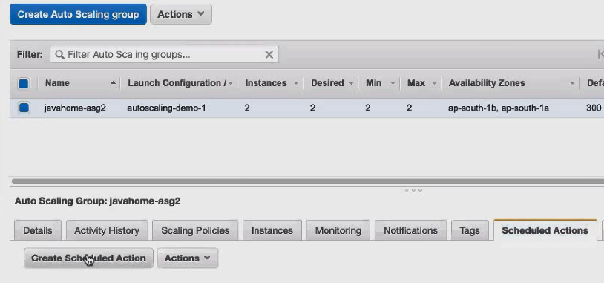

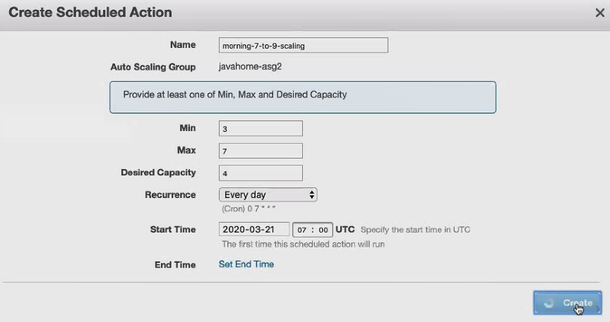

**Health Check Grace Period** : The length of time that auto scaling waits before checking an instance health status.The grace period begins when an instance comes in to service.

**When auto scaling performs scale out** :

1. It launches new ec2 instance
2. EC2 comes to service
3. It starts web server
4. It initialize web application (5 minutes)
5. Our application on EC2 is ready for responding to the clients.

In above scenario to avoid health check failure we nee some grace period

Can we protect EC2 instance from termination when scale in activity occurs in the autoscaling group ?.

Yes scale-in protection in auto scaling group

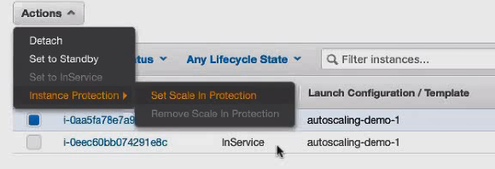

**Default Cool Down:** Number of seconds after scaling activity completes before other can begin,this is also called cool down period**.**

Default value is 5 minutes

For example scale out activity is triggered – add 2 instances

For example at t1+1 minute one more scale out activity triggered --- add 2 instances 🡺this will not happened because of default time is 5 mintues.

How to deploy new application code in to auto scaling group.

**How to deploy a new application version into Auto Scaling Group | AWS Auto Scaling**

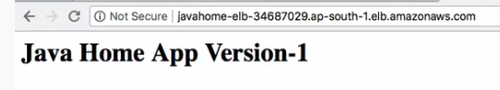

It is having auto size launching configuration with minimum size 1 and maximum size 3

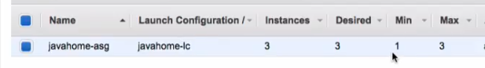

Now we want to release next version to this this auto scaling.

Lets go to the launch configuration : it is a template which contains all the details bout how to launch the new instance in auto scaling group.

Step1 : Create a new launch configuration

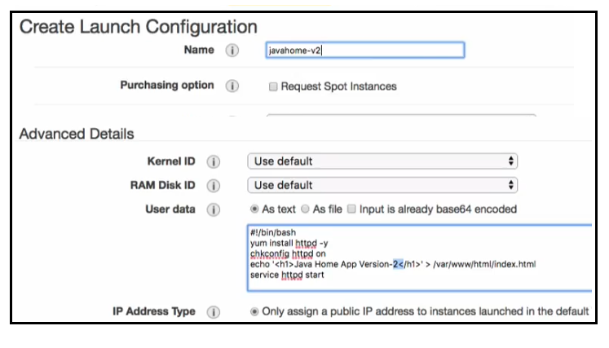

Leave the stoargae group default

Lets go with security group which travels all the traffic.

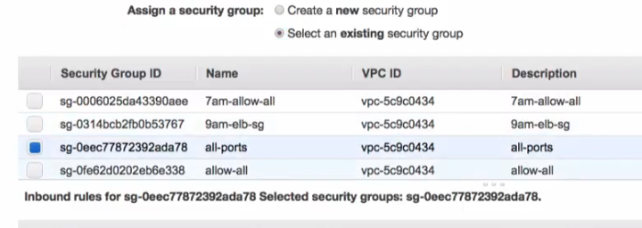

Review ====create launch configuration

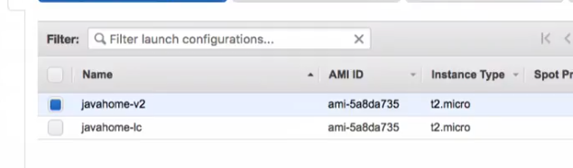

Configuration is done

Step2: Edit auto scaling group

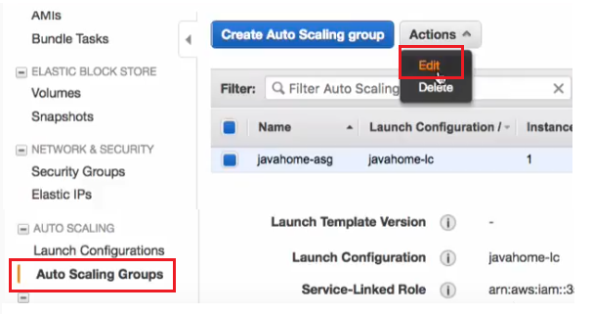

Replace old launch configuration with new launch configuration

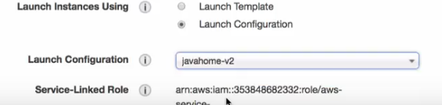

Save it

Step3: Scale out new autoscaling group, its going to add new instances.

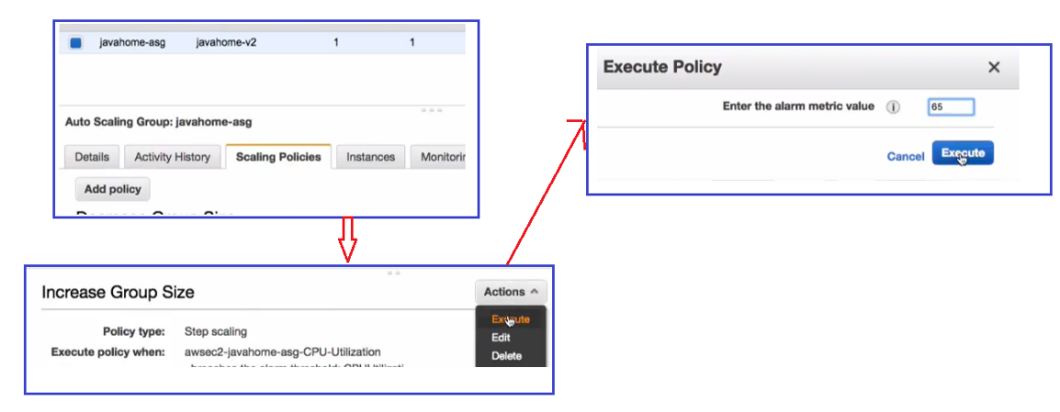

See now desired instances are three.

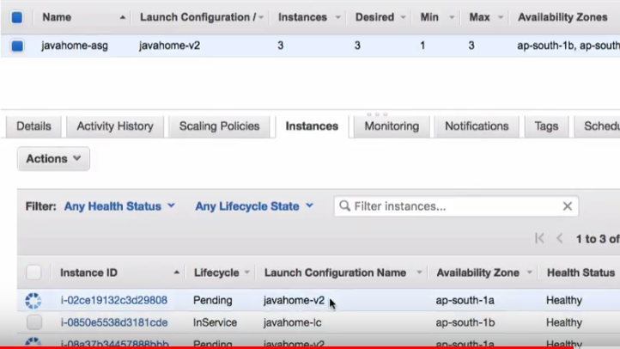

Still we have old configuration see the middle one in above fig. so we have to remove it.

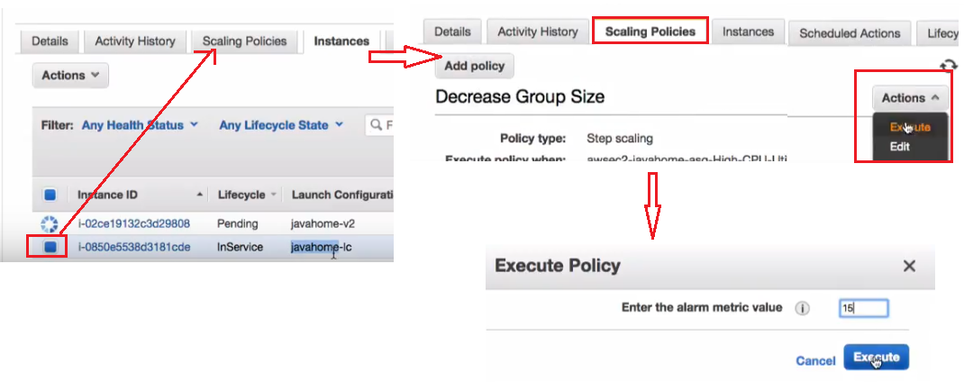

That’s it

